Flask Assignment
Task 1: JSON API Route
- Create a Flask application with an /api route. When this route is accessed, it should return a JSON list. The data should be stored in a backend file, read from it, and sent as a response.
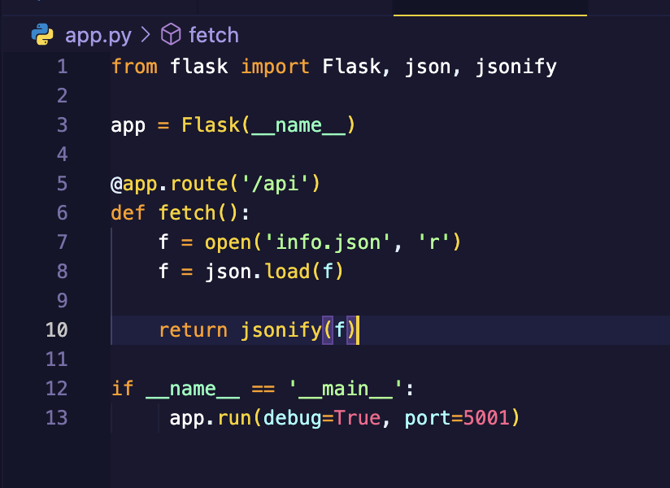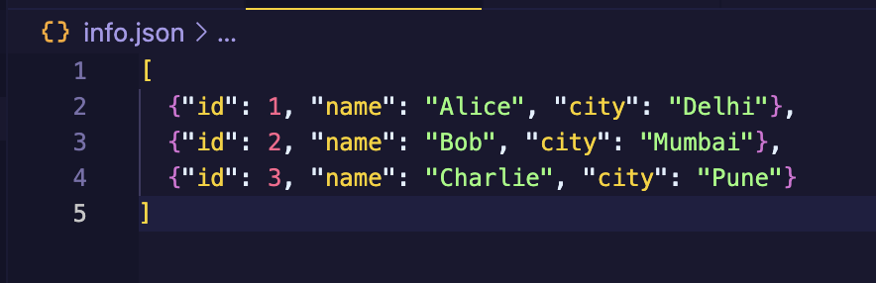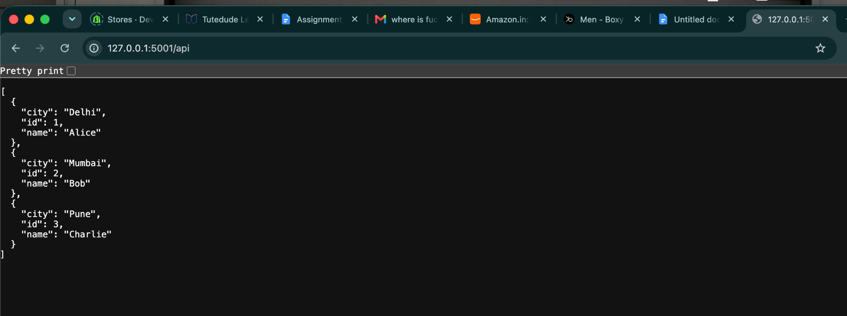
Task 2: Frontend Form with MongoDB Atlas
- Create a form on the frontend that, when submitted, inserts data into MongoDB Atlas.
- On success: the user should be redirected to another page displaying the message “Data submitted successfully”.
- On error: display the error on the same page without redirection.
Index.html file :-
<!DOCTYPE html>
<html lang="en">
<head>
<meta charset="UTF-8">
<meta name="viewport" content="width=device-width, initial-scale=1.0">
<title>Contact Form</title>
<script src="https://cdn.tailwindcss.com"></script>
</head>
<body class="min-h-screen bg-slate-100 flex items-center justify-center p-4">

<div class="w-full max-w-lg bg-white rounded-xl shadow-md p-8">
<h1 class="text-2xl font-semibold text-slate-800">Get in touch</h1>
<p class="text-slate-500 mt-1 mb-6">Fill in your details and we'll get back to you.</p>

{% if error %}
<div class="mb-5 rounded-lg border border-red-300 bg-red-50 px-4 py-3 text-sm text-red-700" role="alert">
<strong class="font-semibold">Couldn't submit:</strong> {{ error }}
</div>
{% endif %}

<form action="/submit" method="POST" class="space-y-5">
<div>
<label for="name" class="block text-sm font-medium text-slate-700 mb-1">Name</label>
<input type="text" id="name" name="name" required
value="{{ form.name if form else '' }}"
class="w-full rounded-lg border border-slate-300 px-3 py-2 text-slate-800 focus:outline-none focus:ring-2 focus:ring-teal-600 focus:border-teal-600">
</div>

<div>
<label for="email" class="block text-sm font-medium text-slate-700 mb-1">Email</label>
<input type="email" id="email" name="email" required
value="{{ form.email if form else '' }}"
class="w-full rounded-lg border border-slate-300 px-3 py-2 text-slate-800 focus:outline-none focus:ring-2 focus:ring-teal-600 focus:border-teal-600">
</div>

<div>
<label for="phone" class="block text-sm font-medium text-slate-700 mb-1">Phone number</label>
<input type="tel" id="phone" name="phone" required pattern="[0-9]{10}"
title="Enter a 10-digit phone number"
value="{{ form.phone if form else '' }}"
class="w-full rounded-lg border border-slate-300 px-3 py-2 text-slate-800 focus:outline-none focus:ring-2 focus:ring-teal-600 focus:border-teal-600">
</div>

<div>
<label for="message" class="block text-sm font-medium text-slate-700 mb-1">Message</label>
<textarea id="message" name="message" rows="4" required
class="w-full rounded-lg border border-slate-300 px-3 py-2 text-slate-800 focus:outline-none focus:ring-2 focus:ring-teal-600 focus:border-teal-600">{{ form.message if form else '' }}</textarea>
</div>

<button type="submit"
class="w-full rounded-lg bg-teal-700 px-4 py-2.5 font-medium text-white hover:bg-teal-800 focus:outline-none focus:ring-2 focus:ring-teal-600 focus:ring-offset-2">
Send message
</button>
</form>
</div>

</body>
</html>
Success.html file:-
<!DOCTYPE html>
<html lang="en">
<head>
<meta charset="UTF-8">
<meta name="viewport" content="width=device-width, initial-scale=1.0">
<title>Submitted</title>
<script src="https://cdn.tailwindcss.com"></script>
</head>
<body class="min-h-screen bg-slate-100 flex items-center justify-center p-4">

<div class="w-full max-w-md bg-white rounded-xl shadow-md p-8 text-center">
<div class="mx-auto mb-4 flex h-14 w-14 items-center justify-center rounded-full bg-teal-100">
<svg class="h-7 w-7 text-teal-700" fill="none" stroke="currentColor" stroke-width="2.5" viewBox="0 0 24 24">
<path stroke-linecap="round" stroke-linejoin="round" d="M5 13l4 4L19 7"/>
</svg>
</div>
<h1 class="text-2xl font-semibold text-slate-800">Data submitted successfully</h1>
<p class="text-slate-500 mt-2">Thank you! We've received your message.</p>
<a href="/" class="inline-block mt-6 rounded-lg bg-teal-700 px-5 py-2.5 font-medium text-white hover:bg-teal-800">
Send another message
</a>
</div>

</body>
</html>

app.py code:-
from flask import Flask, json, jsonify, redirect, render_template, request, url_for
from pymongo import MongoClient
import json
import os
from dotenv import load_dotenv
import certifi
load_dotenv("atlas-credentials.env")
MONGO_URI = os.getenv('MONGODB_URI')
client = MongoClient(MONGO_URI, tlsCAFile=certifi.where())
collection = client["flask_db"]["contacts"]
app = Flask(__name__)

@app.route('/api')
def fetch():
f = open('info.json', 'r')
f = json.load(f)

return jsonify(f)

@app.route('/contact')
def contact():
return render_template('index.html')

@app.route('/submit', methods=['POST'])
def submit():
form_data = dict(request.form)
try:
if not all(form_data.values()):
raise ValueError("All fields are required.")
collection.insert_one(dict(form_data))
return redirect(url_for("success"))
except Exception as e:
return render_template("index.html", error=str(e), form_data=form_data)

@app.route("/success")
def success():
return render_template("success.html")

if __name__ == '__main__':
app.run(debug=True, port=5001)
Form:-
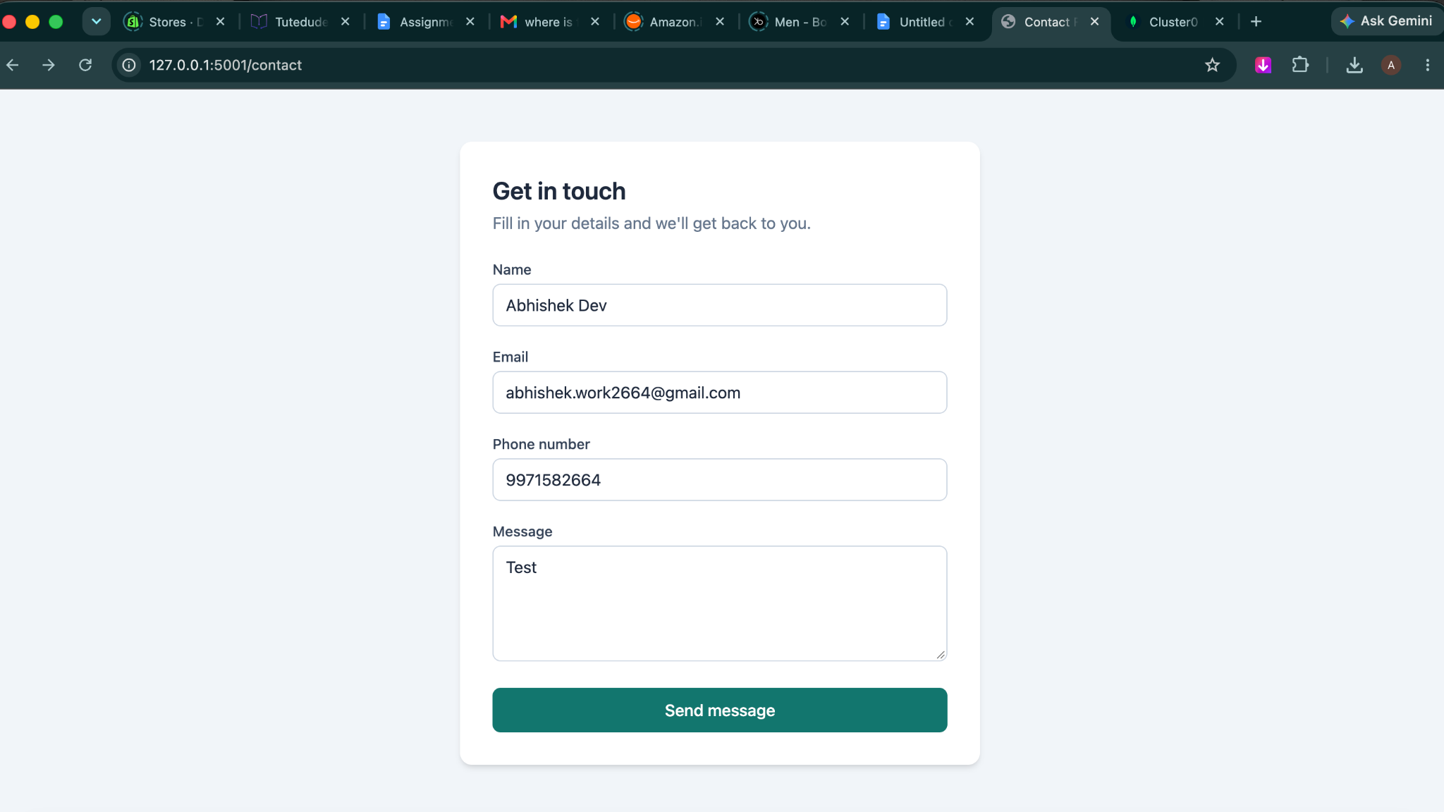

Error Message:-
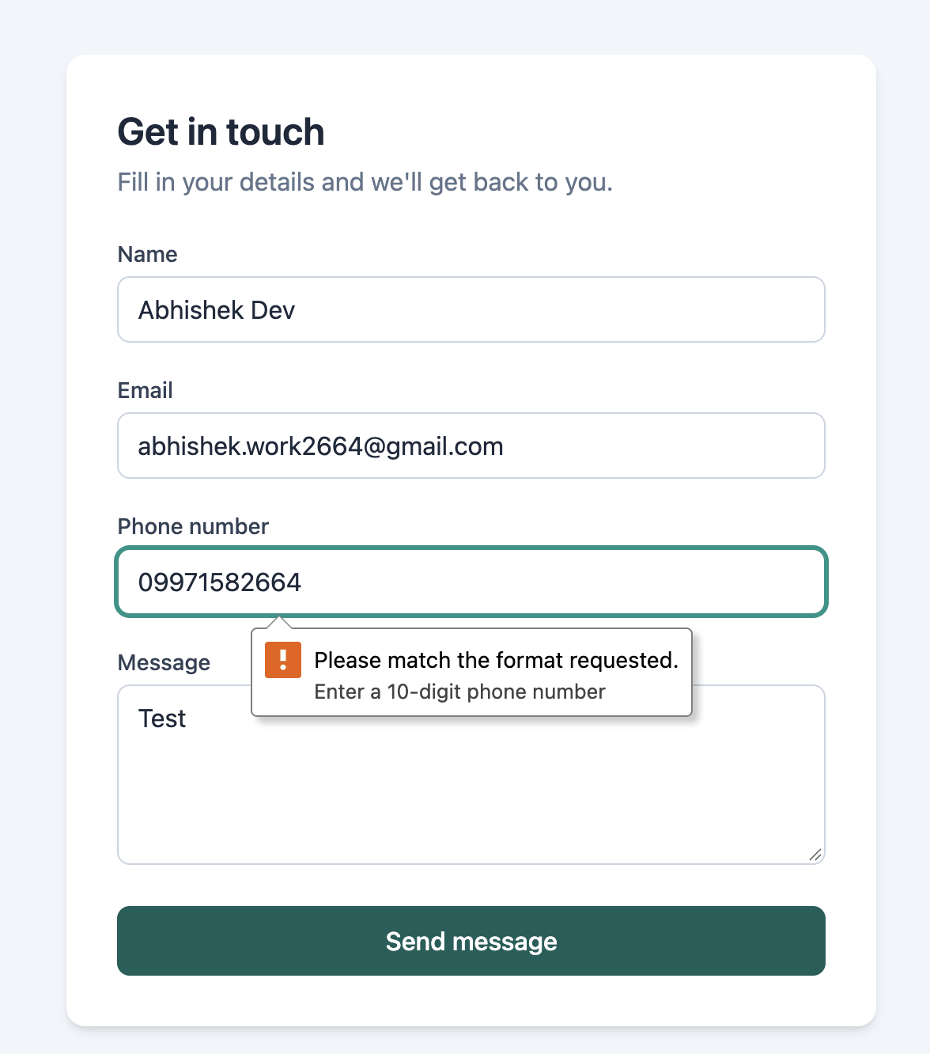

Mongo db panel where the data submitted :- 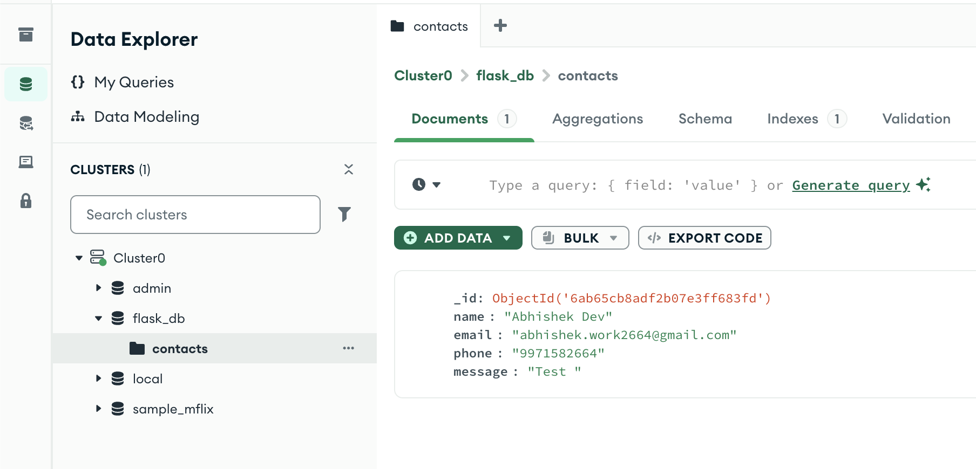

Success Message:-

